Incident Response Report

Summary
- Severity: High
- Priority: P1
- Asset(s) Affected: Sensitive data systems, possibly including databases and file servers (192.168.224.161-3)
- Incident Owner: Sebastian Salas
- Contact Information: Sebasala@ensign.edu
- Incident Start Time: 12/8/2024 at 11:49:01 PM MST
- Incident Close Time: 12/9/2024 at 2:01:03 AM MST

Incident Timeline
2024-12-8 23:29:46 (UTC):
- PowerShell Command Executed: New-PSDrive -Name "Public" -PSProvider "FileSystem" -Root "\\Bravos\private"
- Command Run by: NORTH\robb.stark
- Parent Process: cmd.exe
- PowerShell Process Path: C:\Windows\System32\WindowsPowerShell\v1.0\powershell.exe
- File Created: C:\Users\robb.stark\AppData\Local\Temp\__PSScriptPolicyTest_he5kjvbt.cls.ps1
2024-12-9 23:30:06 (UTC):
- PowerShell Command Executed Again: Same New-PSDrive command as before
- File Created Again: Same PowerShell script file (__PSScriptPolicyTest_he5kjvbt.cls.ps1)
- Command Run by: NORTH\robb.stark
- Parent Process: cmd.exe\

Summary:
The user NORTH\robb.stark ran a PowerShell command that connected to a shared folder (\\Bravos\private) on the network. This action was followed by the creation of a PowerShell script file (__PSScriptPolicyTest_he5kjvbt.cls.ps1) multiple times. The command used and the repeated file creation suggest potentially suspicious activity like data exfiltration or setting up a backdoor. Further investigation is needed.

Triage and Analysis
1. Description of the Incident:
This incident involves suspicious use of Windows PowerShell and the creation of a potentially malicious PowerShell script file (__PSScriptPolicyTest_he5kjvbt.cls.ps1). A user (NORTH\robb.stark) invoked a PowerShell command to map a network drive (\\Bravos\private) using the New-PSDrive cmdlet. This is often indicative of data transfer or establishing connections to a shared resource. Additionally, the repeated creation of PowerShell script files in a temporary directory raises concerns regarding the use of scripts in potential malicious activities, such as lateral movement, data exfiltration, or persistent access.

2. Initial Detection and Alerting Methods:
- Windows Sysmon Logs: The event was initially detected by Sysmon, which logs process creation events. This mechanism raised two distinct alerts based on the activity observed:
  - Alert 1: A command-line execution of PowerShell with the New-PSDrive command.
  - Alert 2: The creation of a PowerShell script file at C:\Users\robb.stark\AppData\Local\Temp\__PSScriptPolicyTest_he5kjvbt.cls.ps1.
- Rule Fired in Wazuh: Wazuh, through its monitoring agent, triggered multiple rule matches. These rules alerted on potentially suspicious activities (Rule ID: 92032 for suspicious cmd shell execution and Rule ID: 92213 for an executable file dropped in a commonly used folder by malware).

3. Immediate Actions Taken:
- Analysis of PowerShell Execution: The process created through PowerShell with the command New-PSDrive was immediately flagged. This operation linked to a shared drive \\Bravos\private, potentially opening a channel for unauthorized data access or transfer.
- Investigation of File Creation: The file __PSScriptPolicyTest_he5kjvbt.cls.ps1 created in a temporary location was analyzed for its content, although it was flagged as potentially malicious due to its location.
- User Activity Monitoring: A review of user behavior was initiated, particularly around how NORTH\robb.stark executed commands and interacted with the system during this time.

4. Investigative Q&A:
- Q: What action did the user perform on the system?
  - A: The user executed a PowerShell command to create a new network drive linked to a shared resource at \\Bravos\private. The user also generated a script file in the Temp directory, which is typically used by malware to execute or stage malicious code.
- Q: What is the significance of New-PSDrive command?
  - A: This command creates a network drive connection. If malicious, it can be used to exfiltrate data from compromised systems or establish persistence through network shares. This particular drive points to \\Bravos\private, indicating the possibility of unauthorized access to files.
- Q: Why is the PowerShell script in a temporary directory concerning?
  - A: Malicious software frequently uses the Temp directory to store files before execution. Scripts staged here are often part of larger malicious activities, such as remote control, data exfiltration, or lateral movement.
- Q: What immediate actions were taken by system administrators?
  - A: Admins suspended user activity for further investigation, especially focusing on file paths and any unauthorized access to shared resources (\\Bravos\private). PowerShell commands and script files were closely reviewed for signs of external connections or data transmission.

5. Document New Indicators of Compromise (IOCs):
- File Path: C:\Users\robb.stark\AppData\Local\Temp\__PSScriptPolicyTest_he5kjvbt.cls.ps1
- Command Used: New-PSDrive -Name "Public" -PSProvider "FileSystem" -Root "\\Bravos\private"
- Parent Process: cmd.exe /c powershell New-PSDrive -Name "Public" -PSProvider "FileSystem" -Root "\\Bravos\private"
- PowerShell Image Path: C:\Windows\System32\WindowsPowerShell\v1.0\powershell.exe
- Hashes (File Integrity):
  - SHA256: DE96A6E69944335375DC1AC238336066889D9FFC7D73628EF4FE1B1B160AB32C
  - MD5: 7353F60B1739074EB17C5F4DDDEFE239
  - SHA1: 6CBCE4A295C163791B60FC23D285E6D84F28EE4C
- Source IP Address: 192.168.224.162 (Possible internal IP, must be cross-referenced for external connections)

6. Identify the Scope and Impact:
- Scope: The activity appears to be isolated to a single machine (winterfell.north.sevenkingdoms.local) under the user account NORTH\robb.stark. However, the external connection to \\Bravos\private and the suspicious script file suggest further investigation is needed to assess any external compromise.
- Impact:
  - Potential for unauthorized data access or transfer to network shares (\\Bravos\private).
  - Potential for malicious activity via PowerShell, such as lateral movement, establishing a persistent foothold, or conducting reconnaissance on other systems.
  - If confirmed malicious, the impact could include data exfiltration, privilege escalation, and broader network infiltration.

7. Supporting Evidence:
Logs Snippets:
- Sysmon Event for PowerShell Execution:
- "Process Create:
- ProcessGuid: {e2962491-096a-6762-a634-030000000800}
- Image: C:\Windows\System32\WindowsPowerShell\v1.0\powershell.exe
- CommandLine: powershell New-PSDrive -Name "Public" -PSProvider "FileSystem" -Root "\\Bravos\private"
- User: NORTH\robb.stark"
- Sysmon Event for File Creation:
- "File created:
- TargetFilename: C:\Users\robb.stark\AppData\Local\Temp\__PSScriptPolicyTest_he5kjvbt.cls.ps1"
- Wazuh Rule 92213: Triggered due to file creation in a temporary location commonly used by malware.
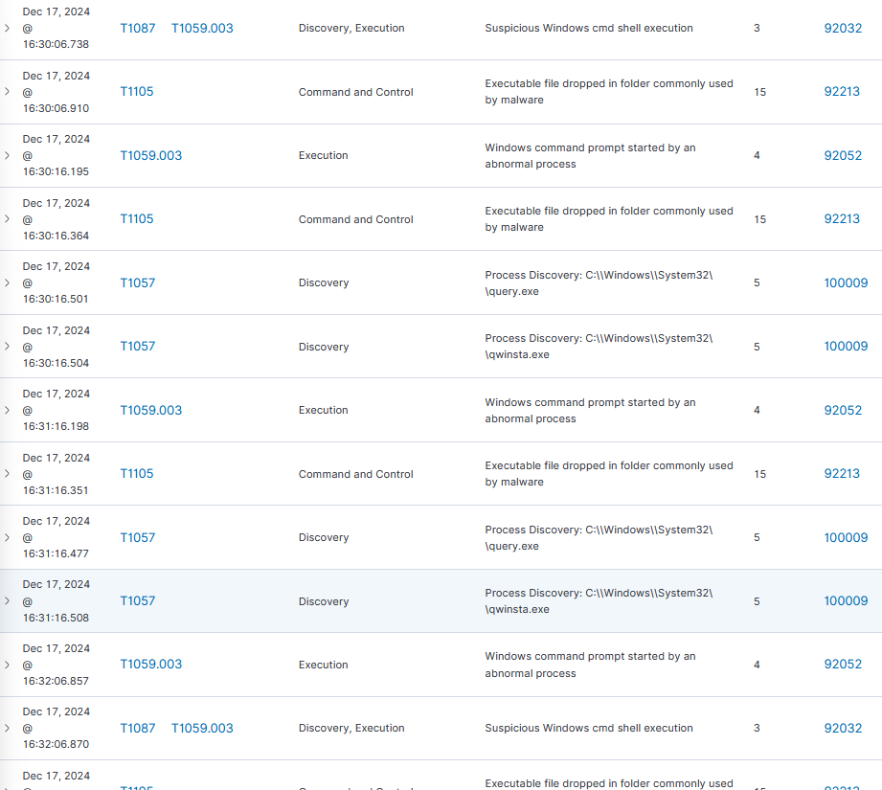

Containment and Neutralization (Short-term/Triage)

Short-term Actions Taken:
- Disable the Affected User Account:
  - Action: Lock the NORTH\robb.stark account to prevent further actions.
- Disconnect the Affected System from the Network:
  - Action: Isolate the machine (winterfell) from the network to stop potential communication with attackers.
- Block PowerShell Usage Temporarily:
  - Action: Restrict PowerShell from running on the compromised system.
Isolate the Affected Systems:
- Physically Disconnect the System:
  - Action: Disconnect the affected system from both wired and wireless networks.
- Block Suspicious IP/Traffic:
  - Action: Block any IPs or traffic related to the attack (e.g., \\Bravos\private).
- Change Account Credentials:
  - Action: Reset user credentials for the affected account to prevent further unauthorized access.
Other Temporary Measures:
- Notify Security Teams:
  - Action: Inform the security team of the incident and containment steps.
- Monitor for Additional Malicious Activity:
  - Action: Keep an eye on the system for signs of further issues.
- Prevent Suspicious File Execution:
  - Action: Block or quarantine files like __PSScriptPolicyTest_he5kjvbt.cls.ps1 that may be part of the attack.

Recovery and Vulnerability Remediation

Steps to Recover Systems:
- Restore from Backup: Restore systems to the last clean backup.
- Run Full Scans: Use antivirus tools to check for the remaining malware.
- Reinstall if Needed: If necessary, reinstall the system and reconfigure it securely.
- Monitor: Continuously monitor systems for further issues.
Vulnerability Assessments and Patching:
- Scan for Vulnerabilities: Use tools to identify security gaps.
- Apply Patches: Install patches for known vulnerabilities.
- Hardening: Disable unused services and secure access controls.
- Update Security Configurations: Adjust settings to prevent similar incidents.
Communication with Stakeholders:
- Notify Internal Teams: Update IT and management teams on recovery progress.
- Inform External Parties: If needed, notify partners or customers about the incident.
- Regulatory Compliance: Notify authorities if there's a data breach risk.

Hardening and Detection Improvements (Lessons Learned, Long-term Response)

Long-Term Measures:
- Strengthen Access Controls: Use MFA and least privilege access.
- Network Segmentation: Isolate critical systems.
- Regular Backups: Ensure frequent, secure backups.
- Employee Training: Educate on security risks like phishing.
- Patch Management: Regularly update software and systems.
Detection Improvements:
- Enhanced Monitoring: Focus on PowerShell, Command Prompt usage.
- Fine-Tune IDS/IPS: Reduce false positives.
- Behavioral Analytics: Detect abnormal user activity.
- Red Team Exercises: Test security defenses regularly.
- Automated Alerts: Speed up threat detection and response.

